**EMBODIED STORYTELLING/’NATURE’ PORTAL WORKSHOP - Erin Cooney**

**Teaching As Art Teaching Day**

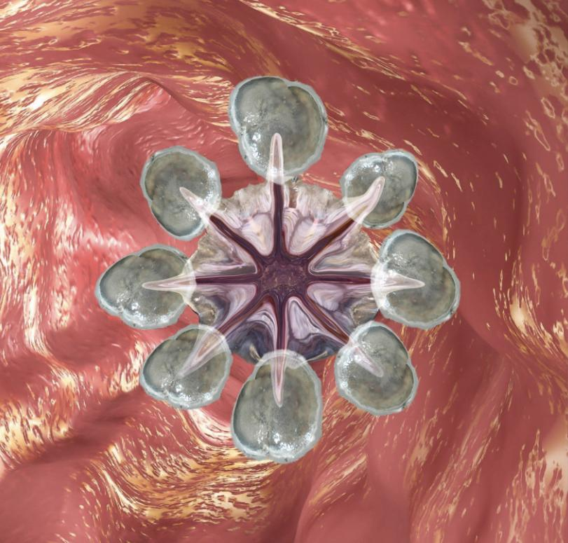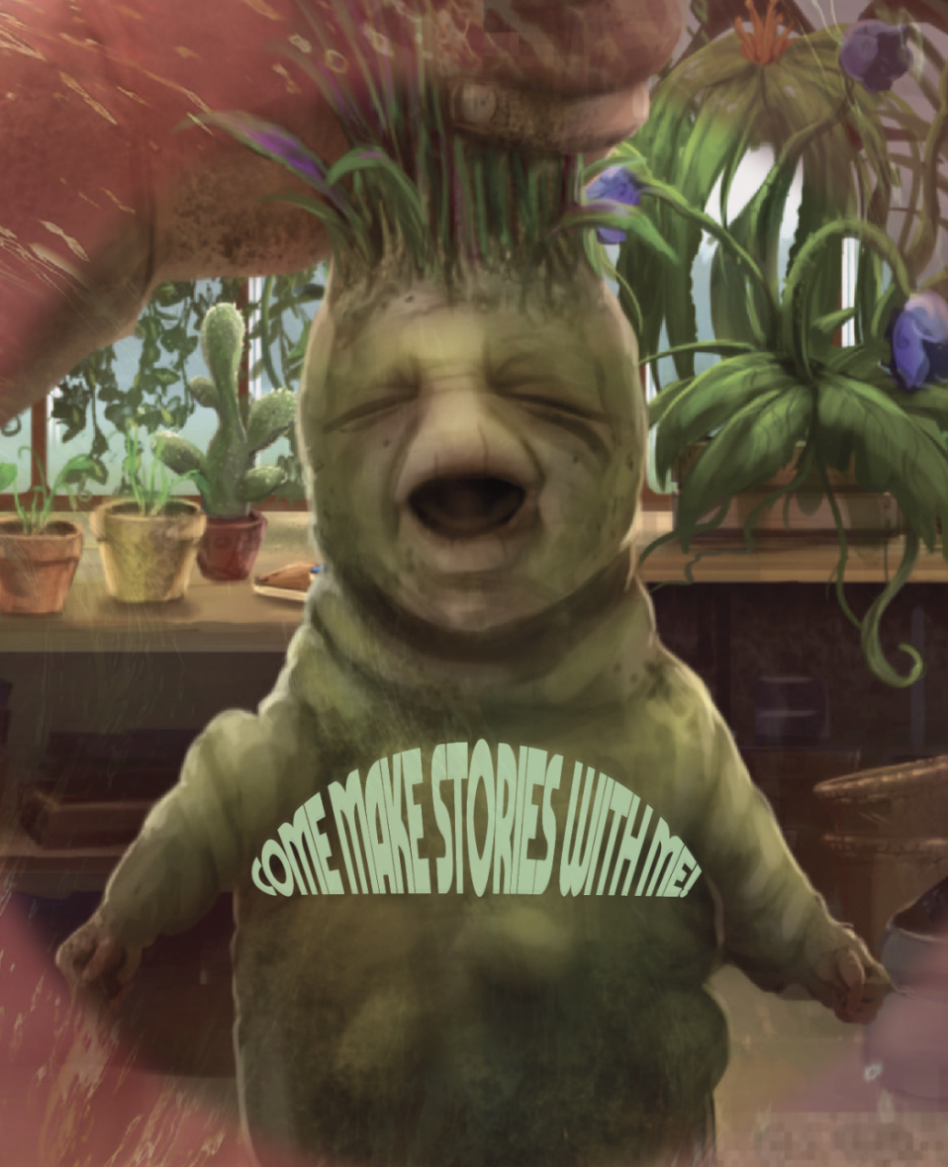

Paideumatic: “the tendency of cultures to be shaped--in their major symbolic inspiration and dominant forms--by their own geography, soil and climate.”

**DESCRIPTION:**

The natureculture divide has given the western world the idea that we are apart from nature, it has been imagined into a construct of an entity outside of ourselves. Before there were separate ideas of nature & culture, and nature was extracted to create culture, culture was made *with* “nature”. There is constant interspecies communication in the animal/plant/fungal world, that humans used to be more intimately entangled with on a wider scale. What kind of energy/information can we receive and what are ways we can prime ourselves to be open to communion with non-humans? Using our whole bodies to commune with, we can find stories/energies throughout our physical selves. Our feelings and emotions live not only in our minds but throughout our bodies. What stories live there? What stories come from “nature” outside our bodies?

Drawing inspiration from our natural tendency as children to be animists, perspectivism, & the ability that story has to collapse time & space as polytemporal beings - we will explore how we can create a state for ourselves that allows stories to emerge. A slow, nebulous, analogue generator/portal.

This workshop combines somatic exercises, communion techniques with nonhumans and creative writing.

**LEARNING OBJECTIVE AND OUTCOME:** A fun and empowering group experience that will offer participants a new tool for composition via connecting with their bodies and “nature”, through breath, visualization, vocalizing, sensing and writing.

**MATERIALS & SETUP: $30-$70**

3 stations: plant, rock, fungus

* Could be a couple of your own houseplants, borrow from a friend or purchase $0-20
* Rocks can be personal collection or collected from a park
* Fungus station has fungus and mushroom tea. I used a large chunk of reishi a friend had foraged and bought a chunk of chaga from etsy that was $20. Tea was a blend of reishi, chaga and cordyceps, probably $10 and cups $5
* I couldn’t use candles because it was run in the library so I used electric tea lights $10
* Various pens and many sheets of paper cut in half from my house $0-$5
* I used a UV blue and red lamp and played a William Basinki album that was droneish that wasn’t too melodic to create atmosphere. Could purchase a colored lightbulb if you’d like to have this effect - $3-$5.

**TIMELINE PREP:**

Collect all material and pack day before. Print out prompts and cut into little strips. Cut writing paper ahead of time. Morning of, make mushroom tea and transport in thermoses - if in another environment, could make tea on premise. Bring laptop, extension cord, bluetooth speaker and a spray with essential oils to spray around the room along with other materials listed above (optional). Anything you think will encourage people to feel comfortable and step outside their comfort zone.

**REFERENCES:**

I wanted to draw from meaningful exercises I had experienced in workshops or read about, but to also make it a unique synthesis I hadn’t experienced. I wanted there to be a compositional aspect as well as a healing, expressive component that also exercised our receptivity. Below are some references that influenced this workshop:

**Eliza Swann & Laura Stinger** of Golden Dome Mystery School:

Eliza - “The Golden Dome School is an educational and curatorial platform dedicated to studying intersections of art, metaphysics, and ecology. The Golden Dome School’s practices seek to destabilize the authority of conventional structures of knowledge and power through an engagement with mysticism and the formation of heart centered communities of learning. We believe that magic has a large role to play in restoring health to people and planet, and that animism* can act as an antidote to capitalism. We encourage a questioning attitude and support intellectual, spiritual, and creative freedom in our work.”

Laura makes work in performance and sculpture. Through movement, their work seeks to channel and trouble the feminized body and enter into a non-rational, cellular space; to question authenticity and explore representation. using text culled from the internet, original writing, and improvised choreographies grounded in the internal logic of the endocrine system the live body itself becomes a radical and charged site to push new queer forms of embodiment.

**Iele Paloumpis** - “Witchcraft: a corporeal practice” at Movement Research: “Several years ago changes in my health and body shifted the ways I approach dance and daily life. Without answers from doctors or bodyworkers, I began looking to witchcraft and earth-based rituals as somatic practices of integration, acceptance and healing. For this workshop we will look to astrology and the lunar calendar, as well as our own unique and defiant bodies to generate restorative movement. Astrological influences have a visceral effect, so we will simply be tapping into what is already there to generate somatic healing. Come with an awareness of something you might like to shed, heal and/or embrace.”

**CAConrad** - SOMA(tic) Poetry Rituals: ““Creating a poem is more important to me than having written poems. The rituals where the writing occurs are capable of connecting us to all consciously enacted ritualistic behavior from the past and future. To me it is the opposite of time travel, it is the halting of time, it is the collapsing of the walls separating us from where we have been, where we are going, and beyond. And this is in the best sense of the word “ritual,” the ritual to find the energy lines under our feet and fire rituals to acknowledge the mysterious and fastened 98.6 degrees Fahrenheit inside every human being no matter where we live. It is through our connection to ritual where the experience is horizontal, where we can imbibe with everyone living and dead and with people yet to be.”

**Pauline Oliveros** - “Deep Listening”:

"an aesthetic based upon principles of improvisation, electronic music, ritual, teaching and meditation. This aesthetic is designed to inspire both trained and untrained performers to practice the art of listening and responding to environmental conditions in solo and ensemble situations"

**Ruth Zaporah** - “Action Theater”:

“Spontaneity: Where does our material come from? The interaction of sensation, imagination and memory. Another goal of this training is to access all co-existing realms of experience, even those our language can’t describe -- the states that can’t be named, that at best, we call “states of spirit”. When we act from an open mind, with the various realms accessible, and express ourselves through body, voice or language, we’re spontaneous. We can travel through primal and emotional states, states of cognition and exaltation, and dream or fantasy states that order phenomena in extra-ordinary ways.”

**Suzanne Césaire** - “Plant-Human”   
At the symposium Year Zero, professor & author Vanessa Agard Jones spoke about Suzanne Césaire who was a Martinican writer, teacher, scholar, anti-colonial and feminist activist, and surrealist. “Drawing upon the Frobenian notion of the Ethiopian type of civilization as vegetal, Césaire claims that the Martinican is, fundamentally and in the depths of consciousness, “plant-like,” tending toward a state of abandon to “the rhythm of universal life””... “evoking plant consciousness for liberation”.

**Debra Disbrow** - “Presence and Storytelling- Physical and Emotional Impulse” workshop @ Earthdance. Using a combination of physical theater, comedy improv, movement, writing and text inspired by Grotowski, Keith Johnstone, Body Mind Centering and others, we will activate our image life and physical and emotional impulses through character, relationship, humor and play. Short theatrical performances will emerge with stories that want to be told.

**INSTRUCTIONS / WORKSHOP FORMAT & SCRIPT:**

**INTRO EXERCISES:**

* Gather in a circle and welcome participants
* Lead a brief body warm-up: Shake our bodies, starting with toes up throughout the body, eventually shaking whole body.
* Roll shoulders back a few times and then forward
* Breath in deeply while raising hands up over head and drops arm down on exhale, repeat 3 times, on 3rd exhale, allow body to dive over and hang downward with knees slightly bent, gently sway and shake head yes and no, rise up vertebrae by vertebrae with tucked pelvis, with head last stacking on top of the spine.
* Roll our heads to the right and then to the left.
* Wipe down our bodies of energies from outside that we’ve collected on the way to the workshop and clap it away in the middle of the circle.

**INTRO TALK:**

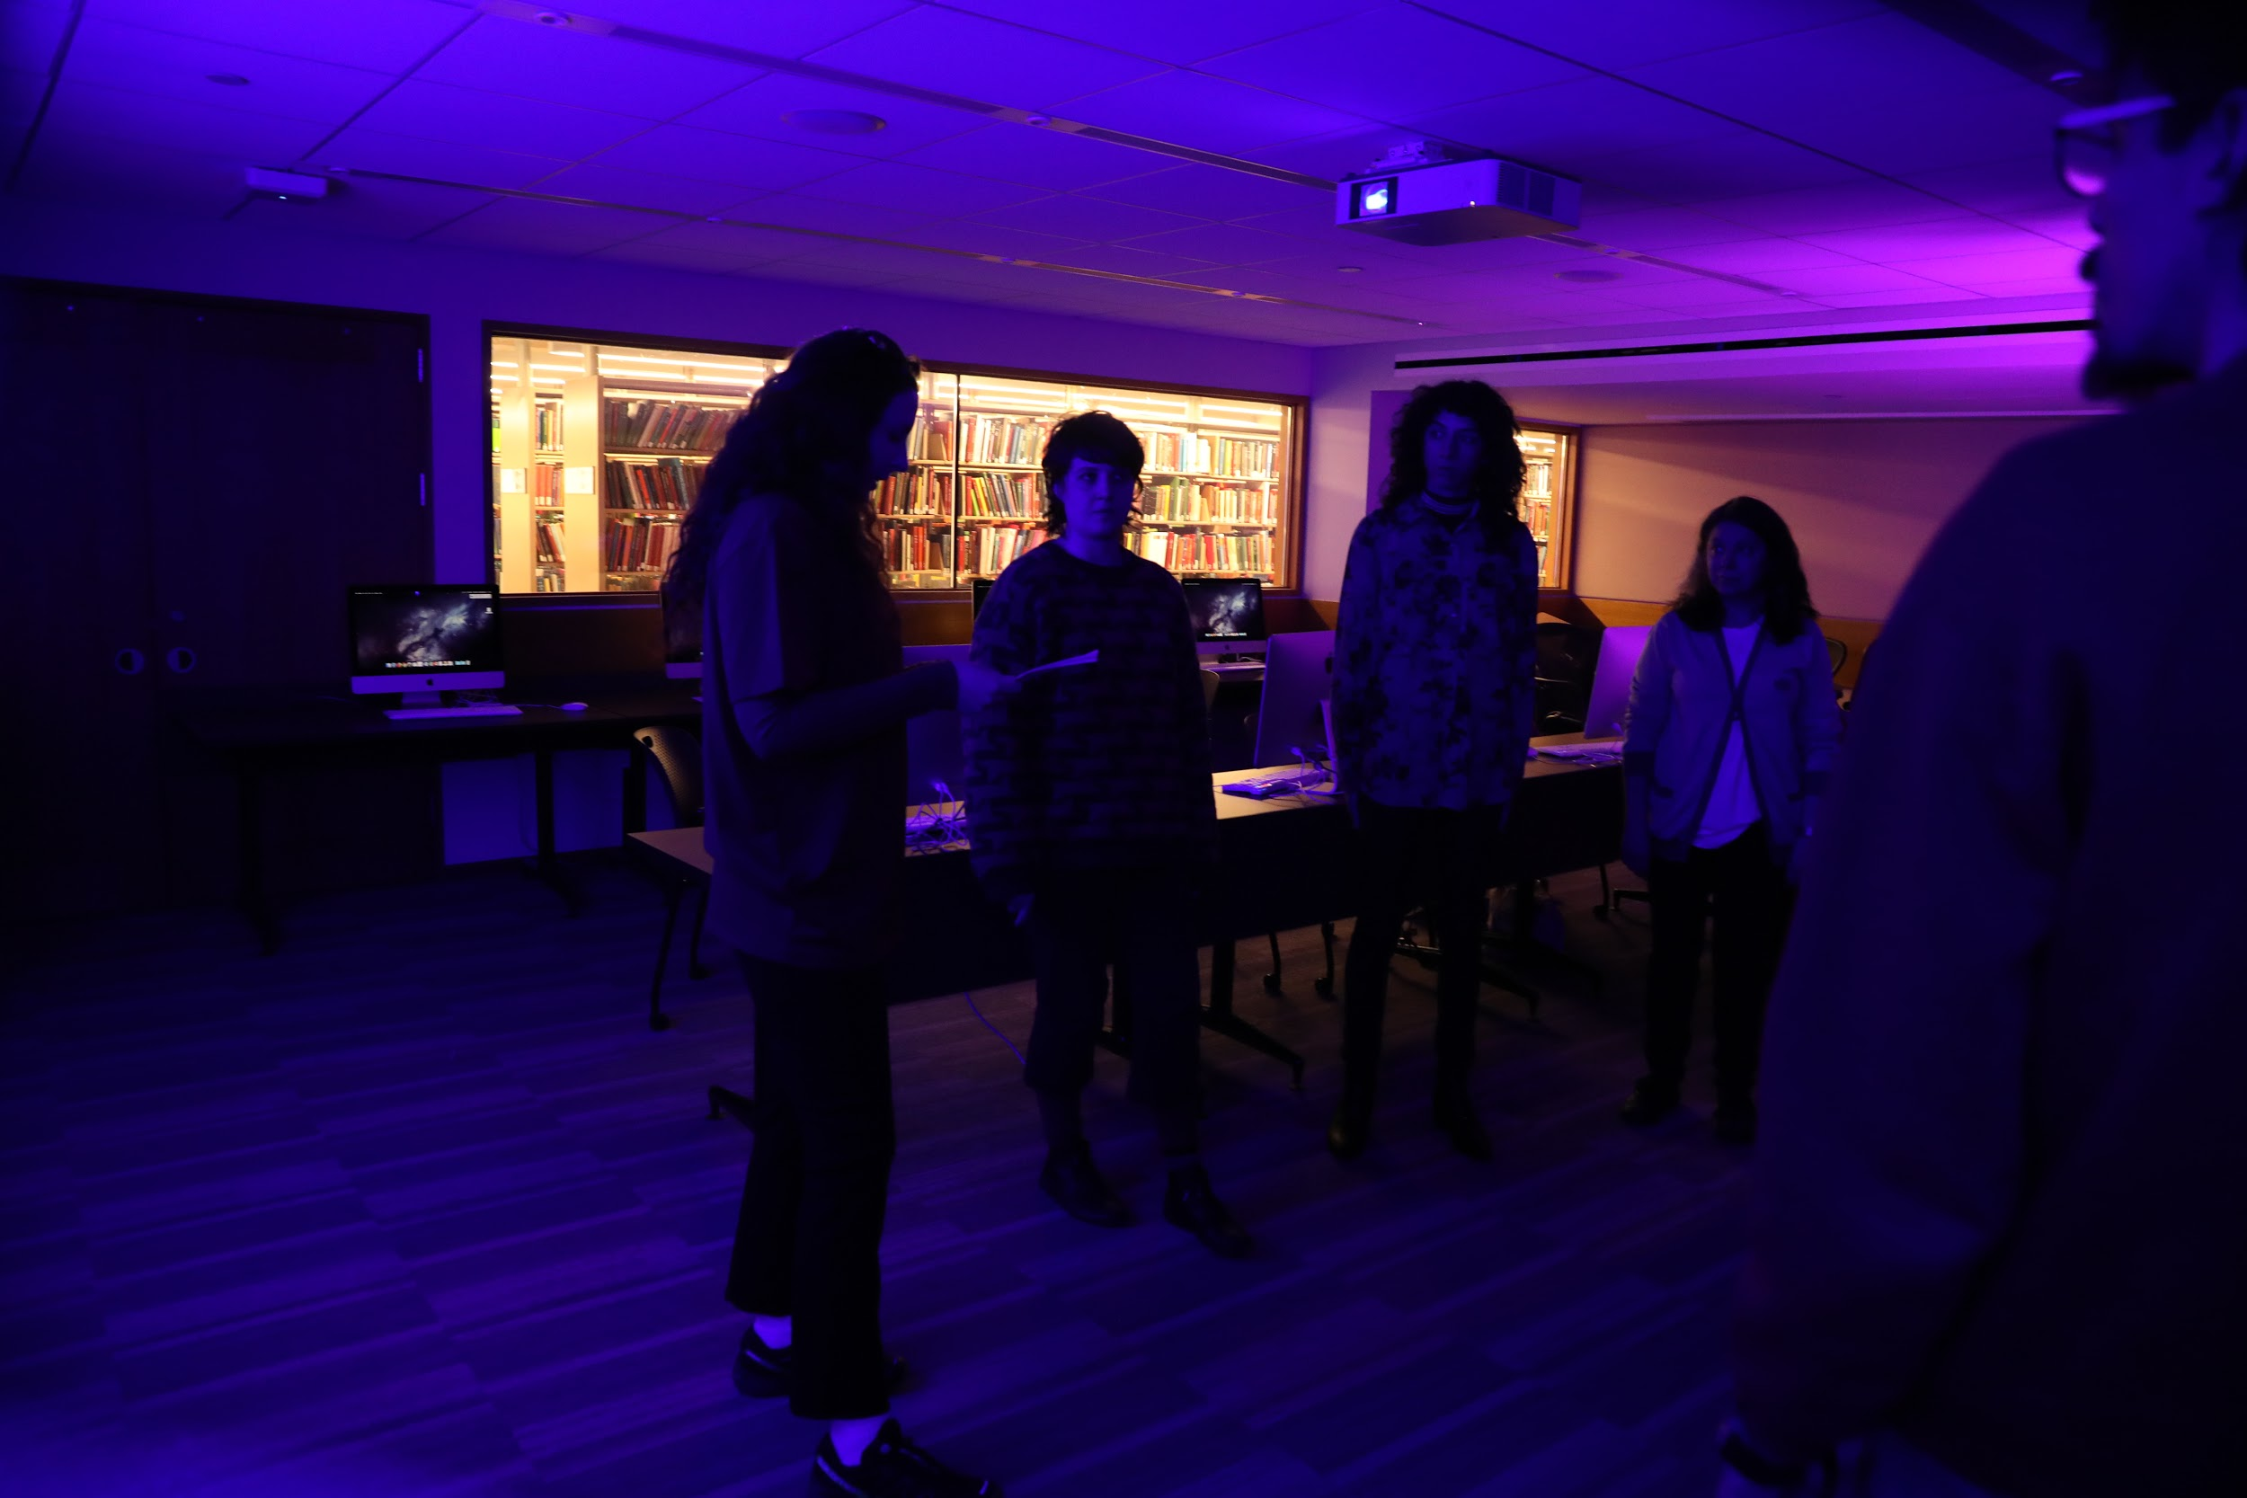

One of the main goals with this workshop is to quiet our critical minds as much as possible using somatic techniques that will allow us to become receptive to non-verbal communication…and also to have fun through exploratory expressiveness. We’ll look to the materials at the stations to help us ground into relaxed but attentive states. Don’t be precious with your reading or writing or anything in the workshop, try to go with the first things that come to you. Any information you receive from the plants, fungus and rocks - it could be poetic, funny, personal, political etc...any sound / words you want to make is valid.

We are drawing from a few different places for this workshop:

* Looking at how mythology was formed and how it was shaped by the landscape.
* “Natureculture” no space, is a newer term that means: “a synthesis of nature and culture that recognizes their inseparability in ecological relationships that are both biophysically and socially formed.” So we’re looking at mending this divide, and dissolve the idea that “nature” as a construct outside of ourselves.
* Perspectivism - trying to imagine & cultivate perspectives outside ourselves that include plant, animal, fungus, bacteria, things...via engagement / channeling.
* The idea that our experiences, our minds, our emotions are stored throughout the body (somatics) and by accessing them information can be released and shifted - and in so doing there is a type of time travel by accessing different temporalities simultaneously.
* Sensing techniques to tune into our bodies and to nonhuman species

**TECHNIQUE OVERVIEW:** There are various nonverbal communication that can be seen in many traditions worldwide, in all different forms, but for this workshop we are going to be using breathing, visualizing, vocalizing, using our hands/fingers & backs as tentacles / receptors. I’m not going to explain everything ahead of time, but i will explain a few things to get started.

* Can everyone count of in 3’s - your number determines what station you start at.
* We are going to open with a body humming exercise and after, you’ll go to your stations. I’ll guide you through the sensing stage and then you’ll take a prompt out of the basket. You’ll then free write for 2 minutes. *Reminder***:** don’t be precious & have fun.

**BODY HUMMING (adapted from Laura Stinger)**:

We’re going to do humming vibrations into different parts of the body and feel the sensations there - so we can feel the physical vibrations of sound and awaken the body connectivity.

* Start with hands on your stomach and tune into what is the sensation there, start by breathing into the area and start to hum into that area.
* Repeat this moving upwards including solar plexus, heart area, right below the collar bone and throat, see how tone wants to change.
* At throat area I suggest people put their hands on their throats to feel the vibration, I then suggest the group to make any sounds they felt like.

* Instruct the groups to go to different stations, they will all rotate to each station throughout workshop *

**RUN STATIONS: (Note: for the people at the fungus station feel free to drink the tea at any point during the exercises, for the people at the rock station you are welcome to hold the rocks)**

**\*** At each station I do a different sensing exercise and talk them through it for a few minutes each. I printed out prompts specific to each table that are optional for participants to use for the free write. They include:

“I’m a plant-person laughing about...”

“I’m a plant-person looking for…”

“I’m a plant-person playing with…”

And the same prompts but from “rock-person” & “fungus-person” perspective* *Some of the sensing exercises below are from Eliza Swann*

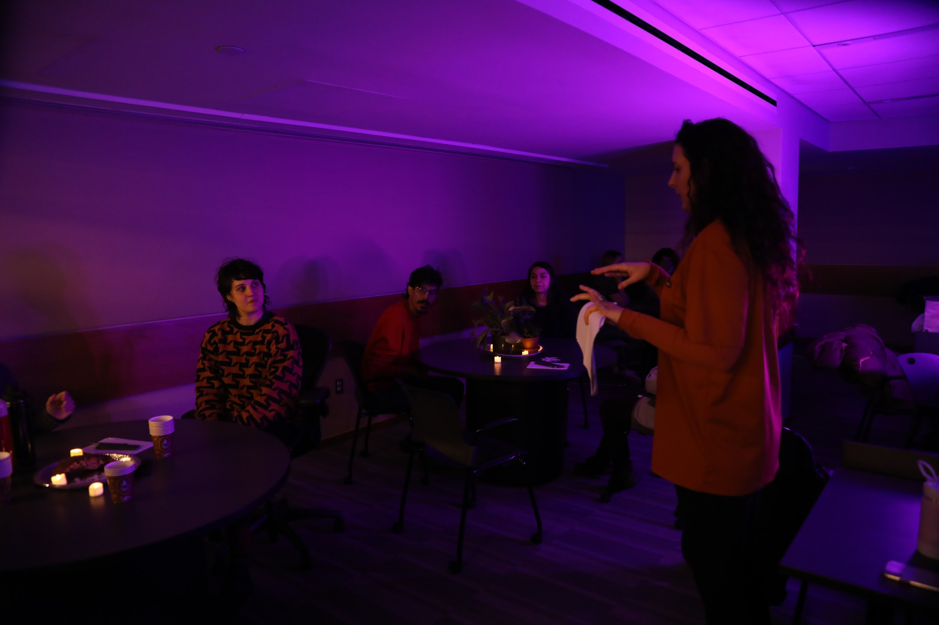

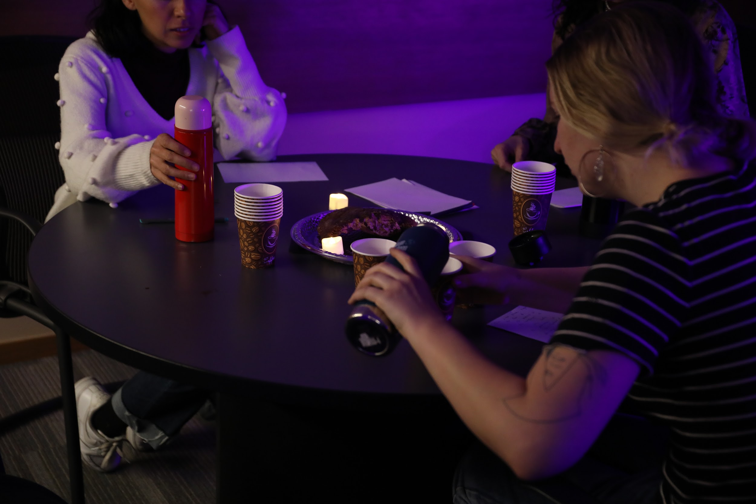

1. At the first station we’re going to take a moment to connect to the station with your eyes in a non-piercing type of way but more of a watery 2-way mirror. Run your hands together briskly to warm them up, then shake them out and close your eyes and sense with your finger tentacles and palms for a few minutes and just see what comes up. Don’t actually touch the objects but hold close like warming a fire (exception for rock group). Take prompt from pile if you’d like and free write for a few minutes - let group know this iteration will not be shared.

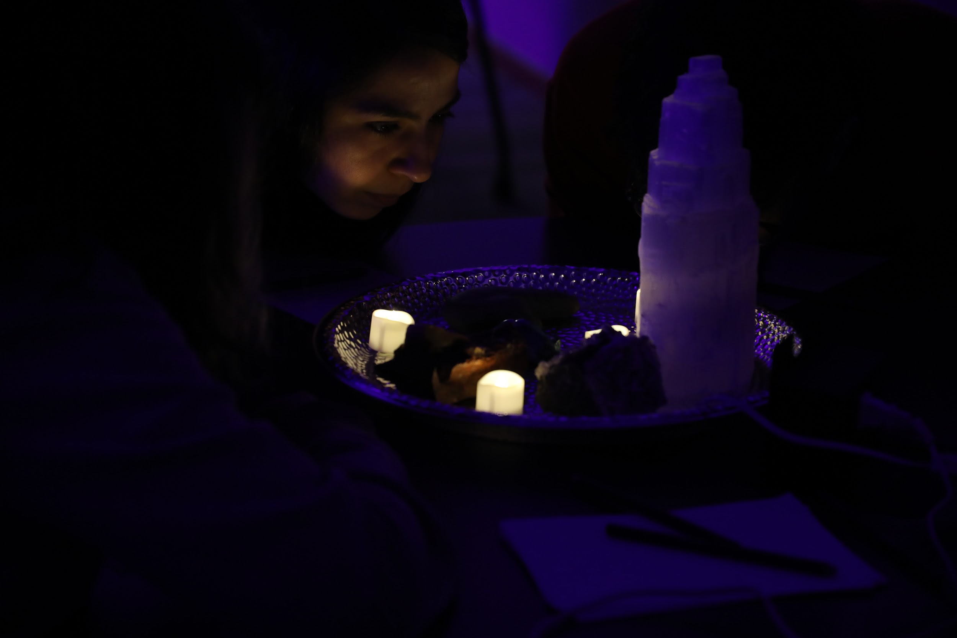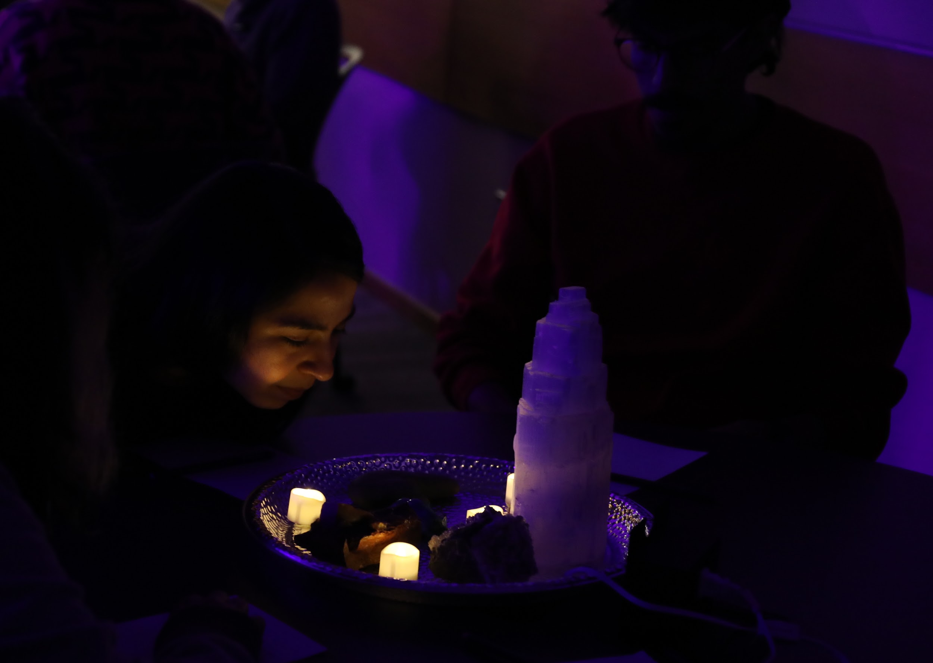

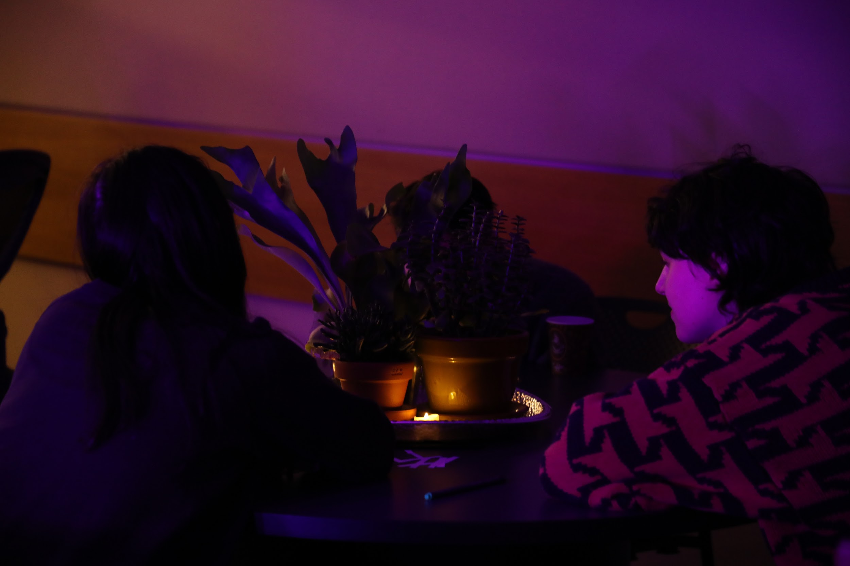

1. At the 2nd station we’re going to take a moment to settle in, close your eyes & when you’re ready, tap into what’s in front of you with the watery gaze and alternate between looking really closely at the objects and then moving out. We’re going to try to identify where in the body this resonates...take a moment to let that reveal itself, if you can’t identify that, just make it up. Maybe there’s a body part it looks like, or a certain area in your body that has a reaction. From that point we are going to start generating sound, what does that part of your body want or need? What sound does it want to make? You can keep alternating from micro to macro gaze and see how that changes the vocalizing. Take prompt from pile if you’d like and free write.
2. 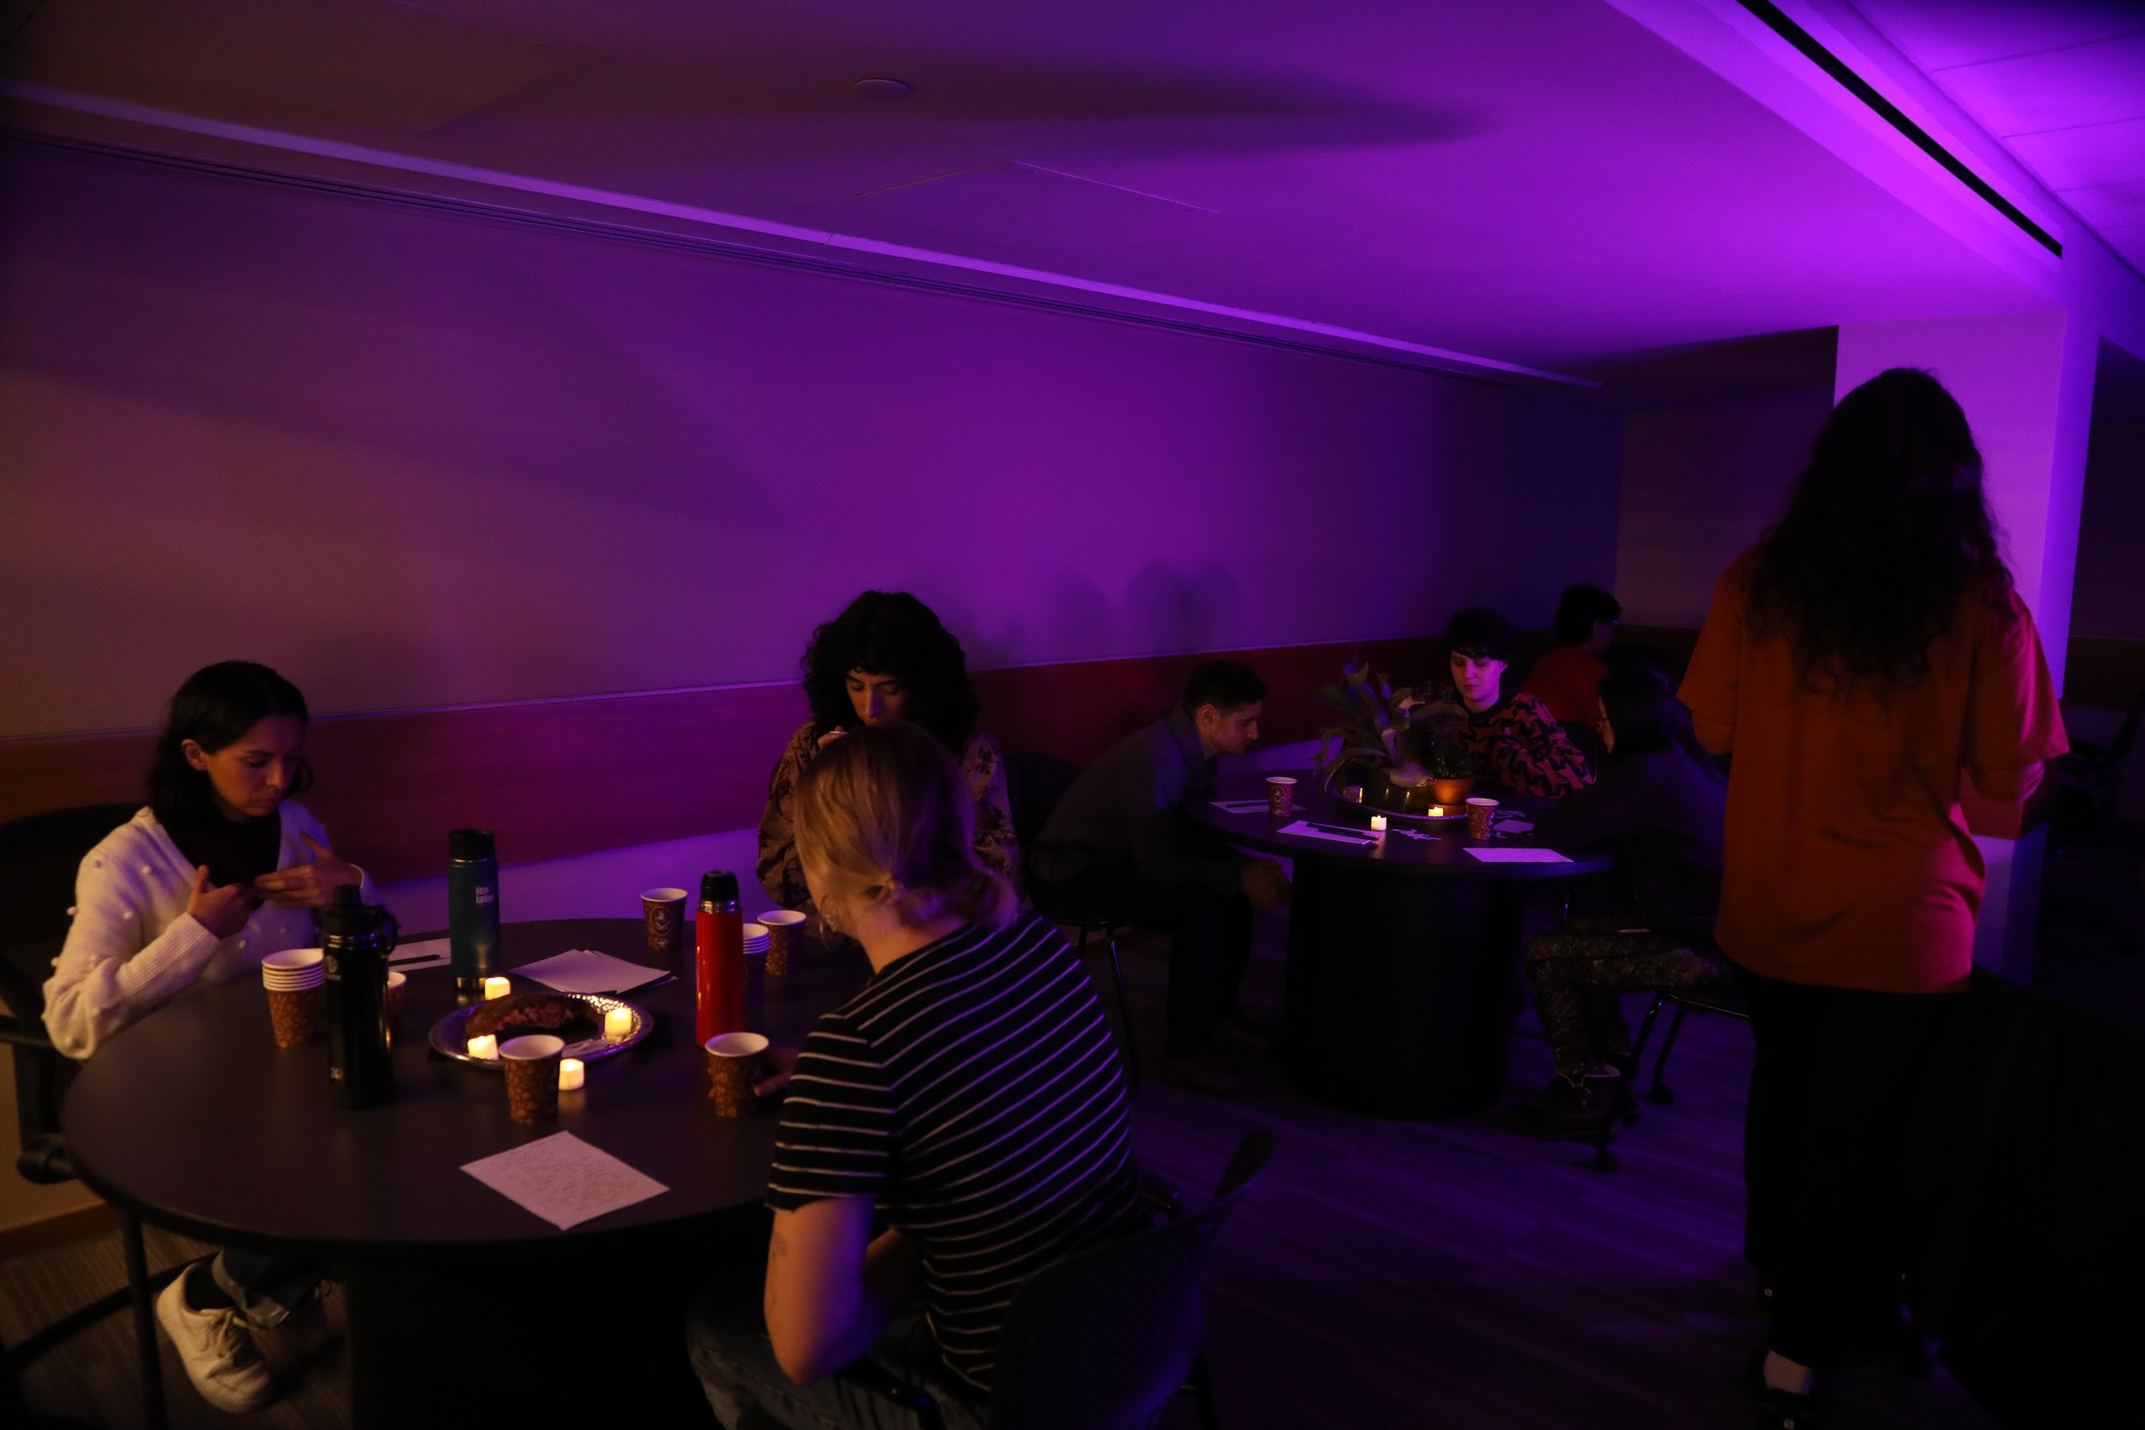

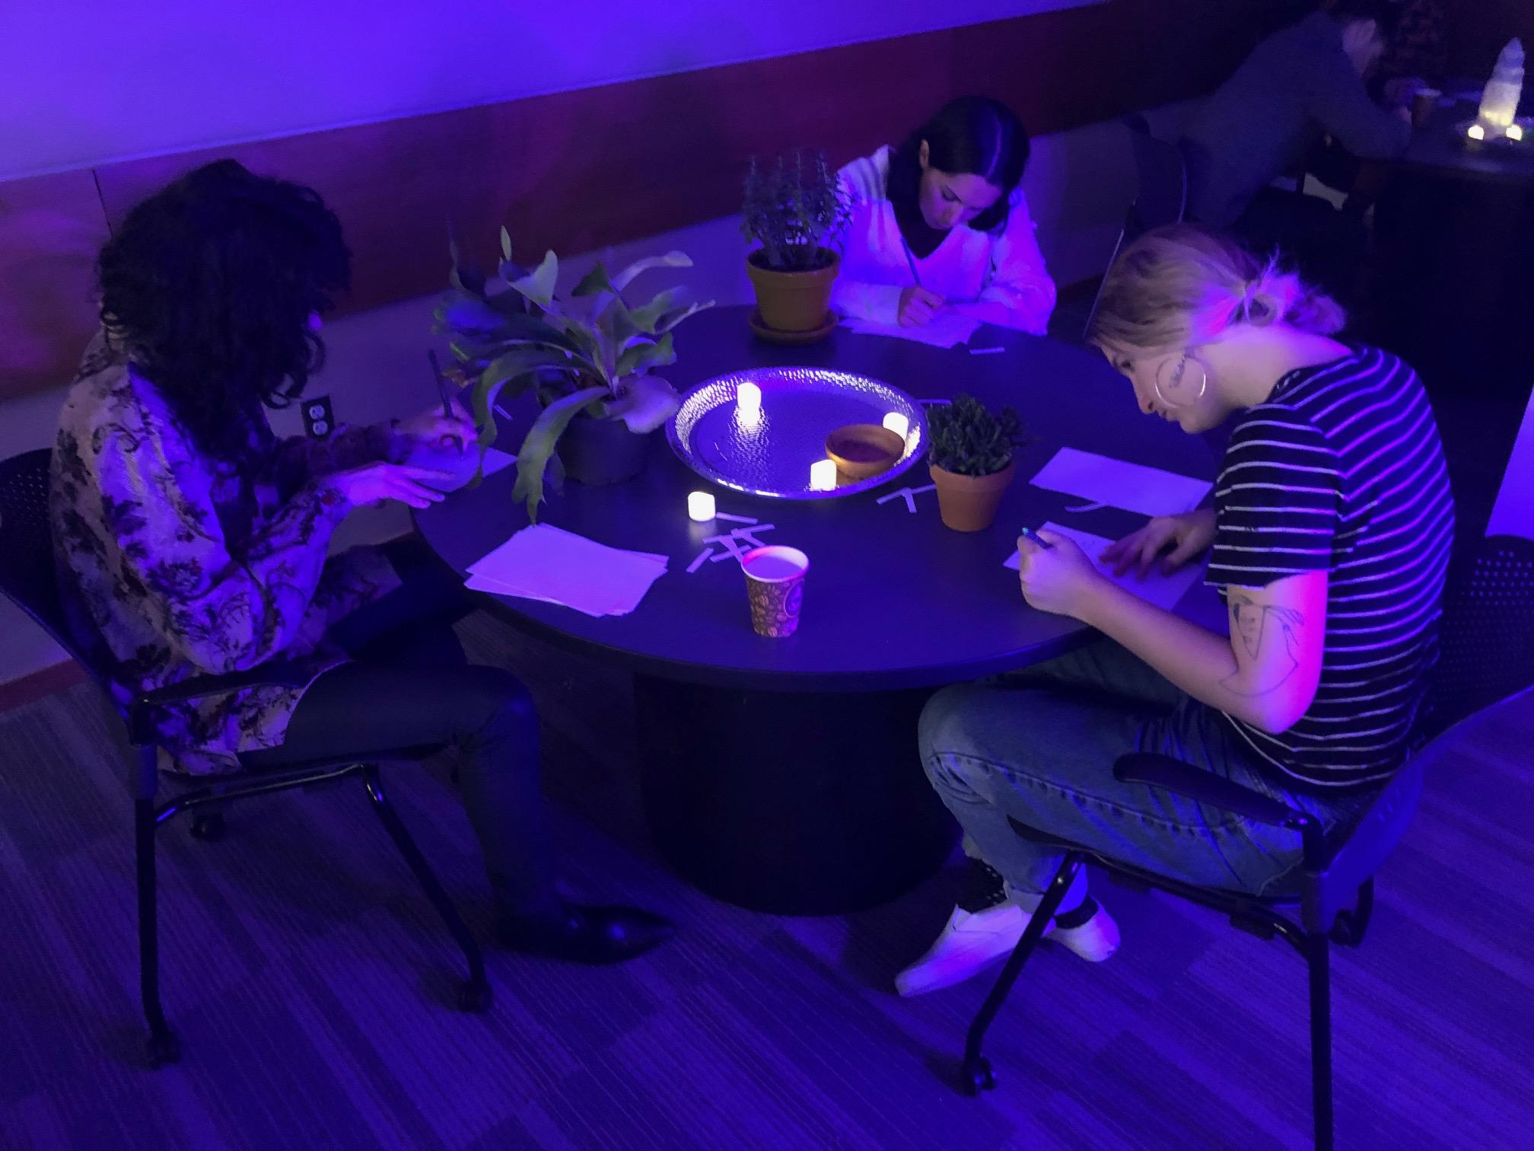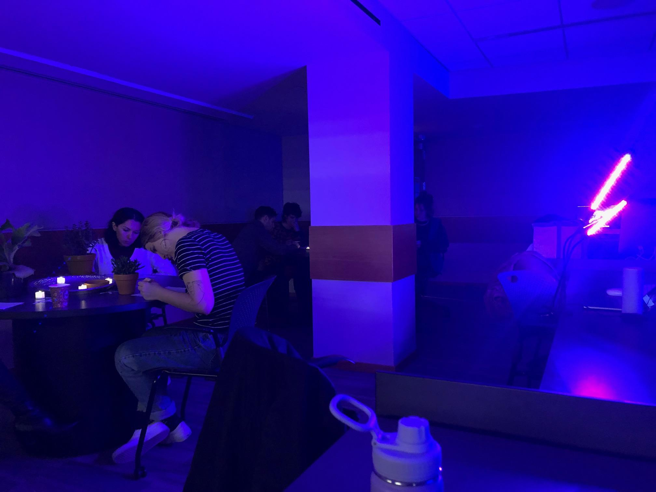

1. At the final station, we are going to be reading with our backs, which are very sensitive to energy but since our eyes are in front of our bodies we favor our frontal plane. Now turn your back to it and let the communion begin, notice the different kinds of information that comes through. Take prompt from pile if you’d like and free write.

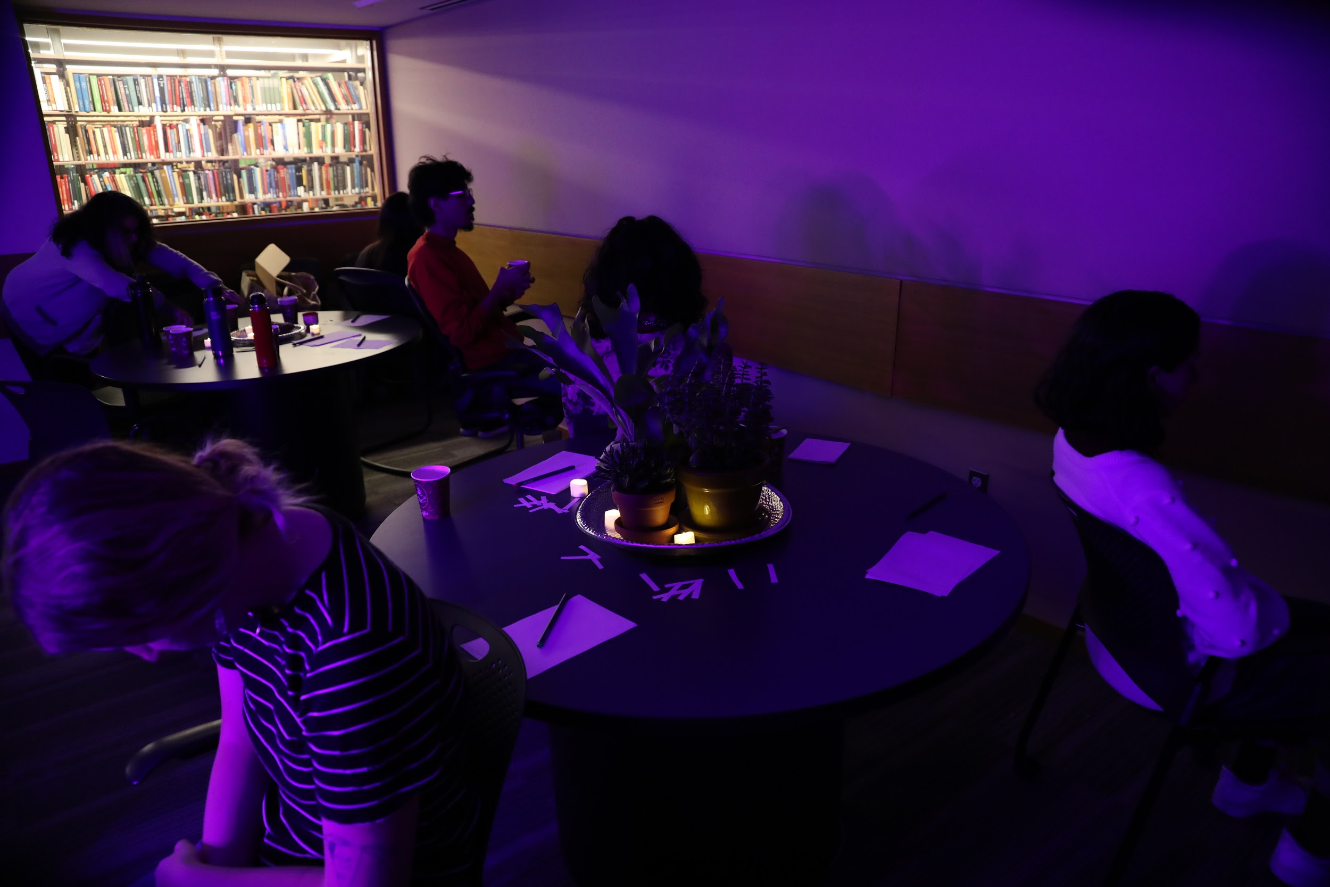

1. Now rotate pens so you have a different color - you’re going to circle all the words, sentences, strings that you like or that pop out at you and then use them as food to make a final writing piece in any style you choose.

**CLOSING:**

* Invite everyone to form a circle and ask if anyone would like to share their readings
* When finished with share, instruct group to close their eyes, take 3 big breathes counting in for 4 and out for 6, letting sound out on all exhalations but the most on the last exhalation
* Shake hands in the middle, imbue it with all the energy that was cultivated, lift your hands up to the sky and send the energy to anyone that needs it and bring some back down for yourself.

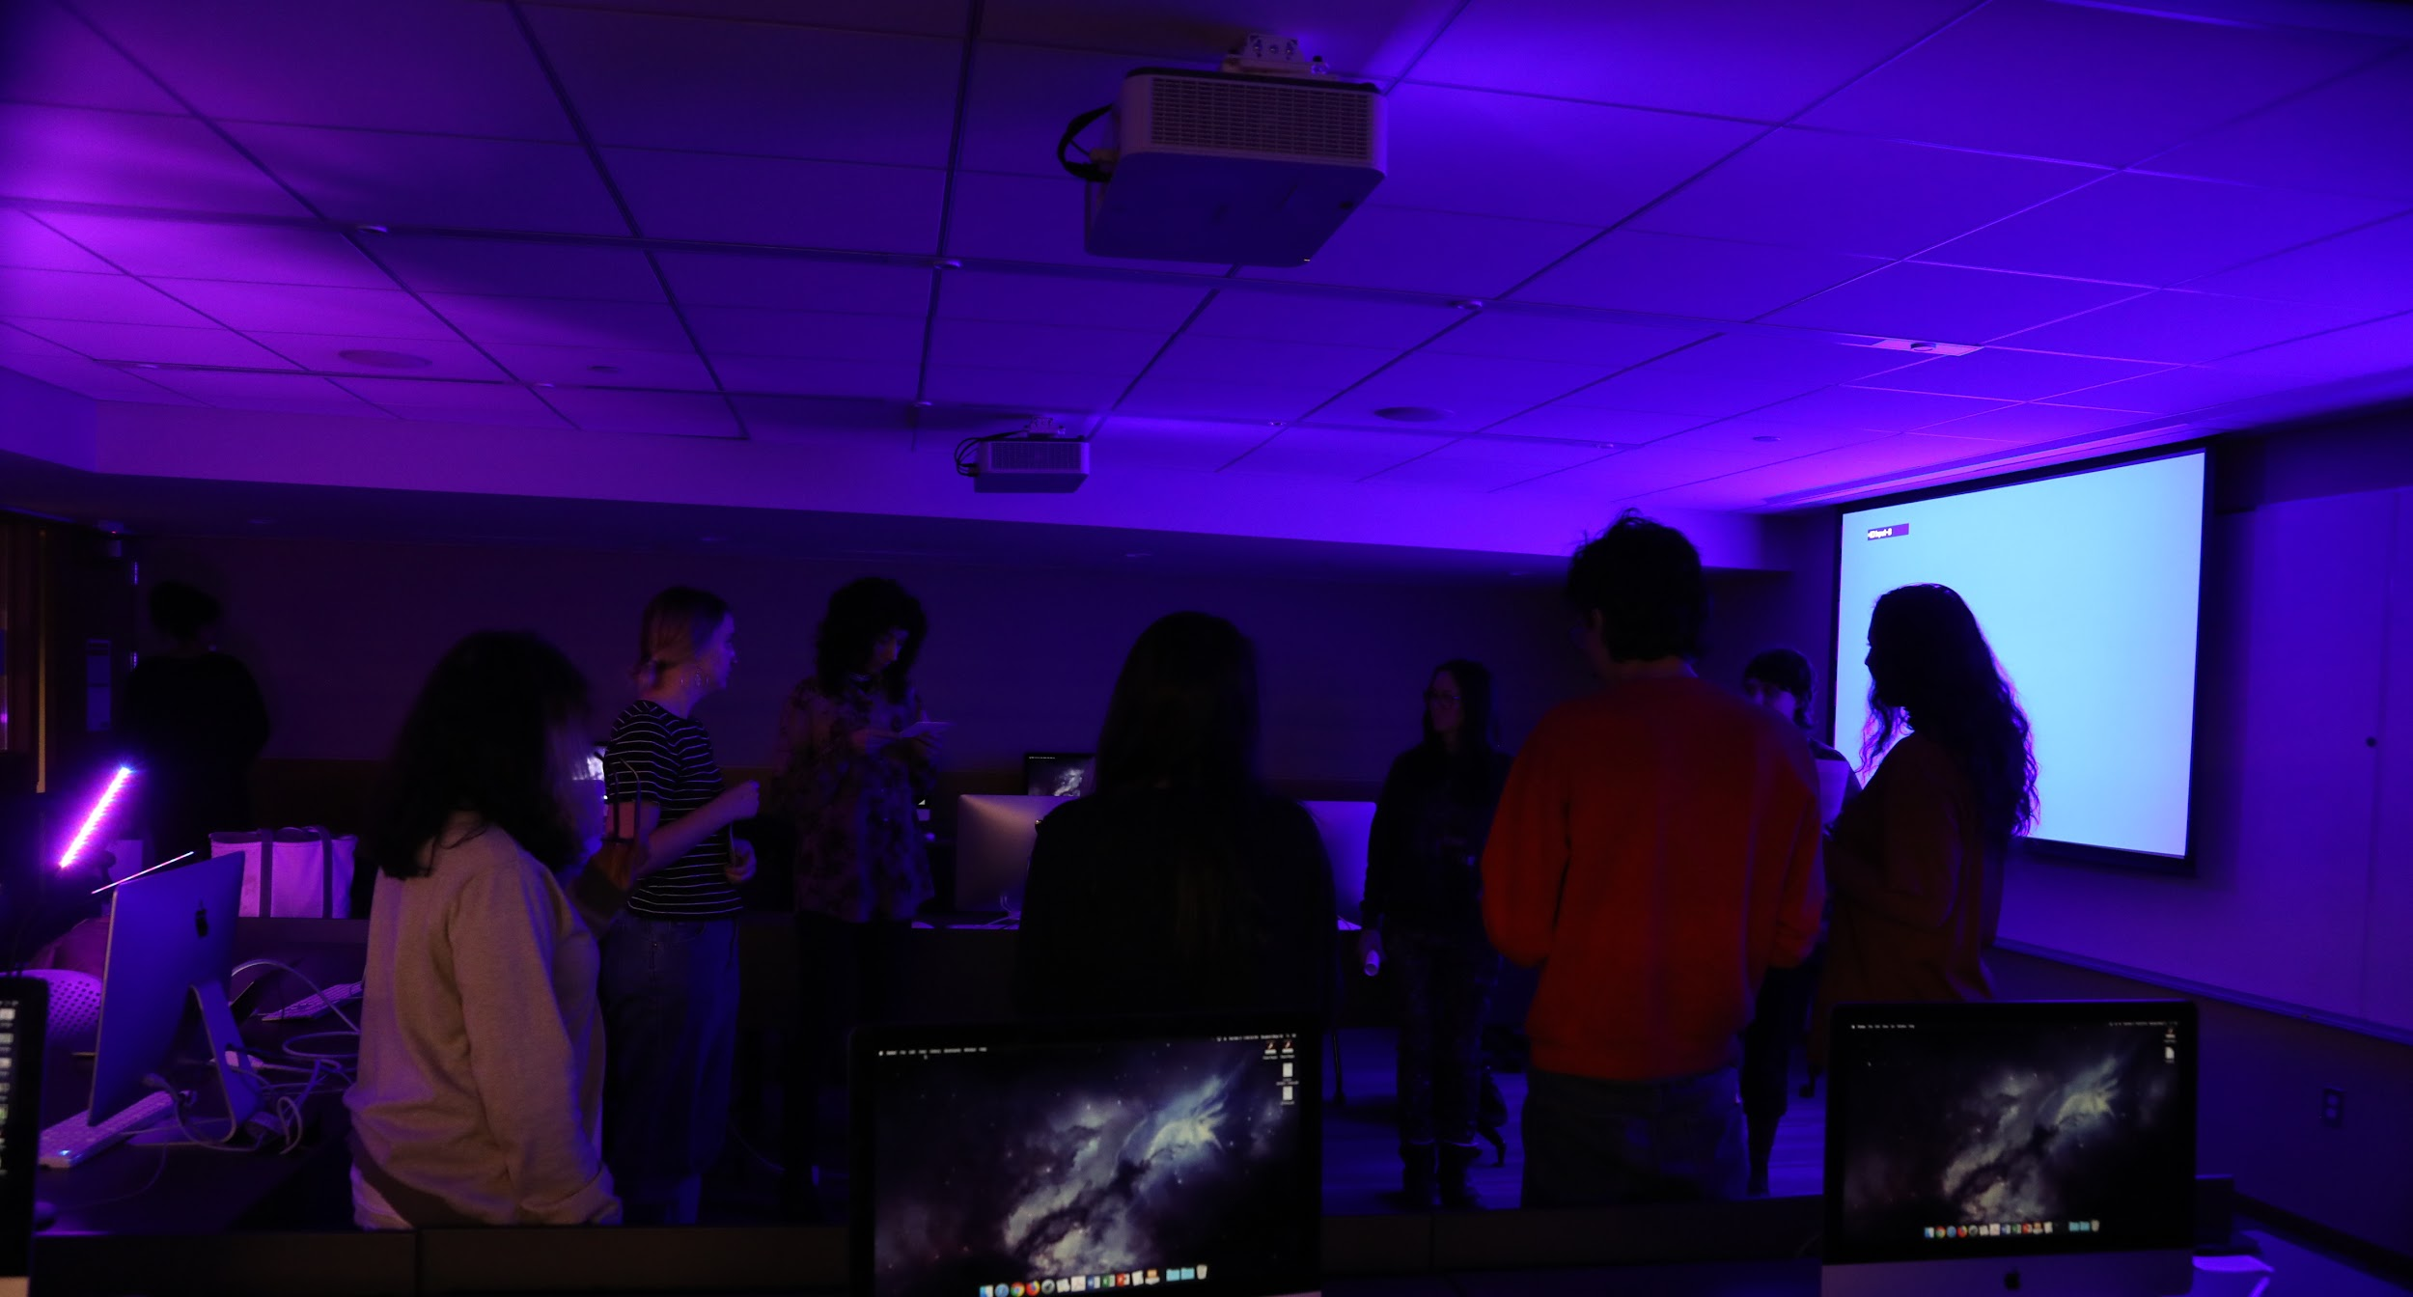

**REFLECTION:** I had a really great time planning and running this workshop. I was nervous that the location would take away from the concept but I think I was successful in transforming the space to be conducive to what I was asking the participants to do. The first 3-5 minutes I felt nervous but afterwards I felt very comfortable running it and the flow felt pretty cohesive and smooth. I did many edits to this workshop in order for it to run smoothly, I talked through it with a couple friends and then did a dry run with a friend the night before which was really helpful - they gave me great feedback on shaping it. I was really happy to share experiences that have been meaningful to me with others and also to create something new within these frameworks.

**PARTICIPANT FEEDBACK:**

**What was your overall experience of the workshop?**

* It was really refreshing and interesting. The activities were unfamiliar for me but the guidance was very effective. The tea was amazing!
* i enjoyed it very much
* a respite. relaxing and meditative.
* I really appreciated the opening exercise as an opening for the workshop. By the end of I definitely felt more receptive and heart-opened

**What are the takeaways from it? Would you use this or a similar technique in general &/or for making compositions/stories/seeds?**

* The warm up exercises, especially the humming, were really effective in changing my state of mind. I think that is something I might use in the future. The process of listening and communing with material and non-humans was both unusual (I had never done that before) and inspiring. As a tangential note, I was reminded of the workshop watching Herzog's Into the Inferno, one of his movies about volcanoes. He interviews people around the world and many describe the relationship they have with the volcano, with some describing how they communicate directly with it.
* the importance of ritual as a way of being present, and as a way to ignite and channel creation. i'd like to keep trying it.
* A reminder to take a moment and appreciate the interconnectedness of natural things.
* Embracing non human perspectives is something I've always *thought* I've done but I think this workshop showed me how I could bring greater awareness to all living things (and non living?) as existing together from a less human-centric perspective

**Are there any areas that could be improved upon?**

* I realize this was something out of your control, but I wonder how a different atmosphere would affect the workshop? As in, not a library? What's the ideal space? Along the same lines, I don't know if it was by design or because of space, but I also wondered how the experience might be heightened or different if we moved between the groups of items by ourselves instead of as groups.
* the classroom was not ideal, but it was transformed in a very nice way. having more time (overall, for each activity) would have been great - but i also liked how many things happened in the session. the vocalization part was super interesting / intriguing / reconnecting - i wonder if there is a way of doing more of that, or exploring how to transition from that state to the more "logocentric" aspect of the writing.
* I think it worked very well in that classroom surprisingly. Maybe at the end we could all mix our end writing up and grab one and read it so they're anonymous (also changing perspective so they're all communal somehow?) maybe just saying this bc I got shy about reading mine in the moment!

**Is there anything you'd like to see added to the experience?**

* I didn't know anything about reading when I came to the workshop, which seemed okay. Would it be helpful to add a reading list or introduction to complete novices?
* Could be interesting to try it in an outdoor space or like in a park. Not really a suggestion for improvement on it as it was but would like to experience something like this outdoors as well

**What was a highlight for you and why?**

* When I closed my eyes at the plant table I could see the blue/pink source of light so vividly. It was really unexpected and intense!
* the vocalizing experience - it was a highlight because it made me realize/remember how easy it is actually to reconnect, and how many barriers we have built in our "civilization" that prevent us from "just being" the sensing activities, and being in an environment that encouraged / embraced them, was also a highlight - letting "reason" fade away...
* The soft, mirror-gaze exercise. I was reminded of my tendency to always sharply analyze and examine details. I was able to see things I usually don't by softening my gaze.
* I think the highlight for me was feeling more opened afterwards on a visceral level

**Were there any parts that were challenging?**

* I don't spend any time creative writing, so that was challenging.
* not really. more time to go deeper into the exercises would have been nice.
* I have been staying up really late and the time of day was not late but is not my most awake but it made me feel a lot better than I did going in!!!